
RAMAIAH
Institute of Technology
USN | 1 | M | S

(Autonomous Institute, Affiliated to VTU)
(Approved by AICTE, New Delhi & Govt. of Karnataka) Accredited by NBA & NAAC with ‘A’ Grade

MAKEUP EXAMINATIONS – JULY 2019

Course & Branch | : | B.E. : Computer Science and  Engineering | Semester | : | IV
Subject | : | Design and Analysis of Algorithms | Max. Marks | : | 100
Subject Code | : | CS42/CS1542 | Duration | : | 3 Hrs

Instructions to the Candidates:
- Answer one full question from each unit.

 |  | UNIT- I
1. | a) | Define the following terms with respect to stable matching algorithm with an example.  - Matching  - Perfect Matching  - Instability  - Stable Matching. | CO1 | (06)
 | b) | For the following Competitive Facility Location problem, check if the Player-2 has the winning strategy or not for the target 35 and 40 if the Player-1 plays first.  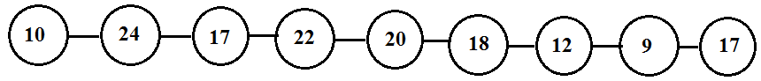 | CO1 | (06)
 | c) | Explain the different asymptotic notations used to represent the algorithms running time with examples. | CO1 | (08)
2. | a) | Prove the following:  “Let f be a polynomial of degree k, in which the coefficient a_{k} is positive. Then f= O(n^k)”. | CO1 | (06)
 | b) | What is a bipartite graph? Discuss with an example how the bipartite graph can be used to express the concept of stable matching? | CO1 | (06)
 | c) | Prove that "Every execution of the G-S algorithm results in the set S*". | CO1 | (08)
 |  | UNIT- II
3. | a) | Explain the below approaches to solve recurrences:  - Unrolling the Mergesort recurrence  - Compute the topological ordering for the following graph  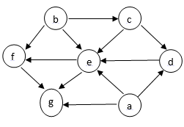  Fig.3(a) | CO2 | (08)
 | b) | i) Prove that if G is a DAG, then G has a topological ordering.  ii) Compute the number of inversions for the following set of numbers | CO2 | (07)
  4 | 3 | 2 | 5 | 7 | 1 | 6 | 9
 | c) | Write Depth First Search algorithm and find its worst case efficiency when graph is given by adjacency list representation.1 | CO2 | (05)
4. | a) | Design an algorithm to determine whether a given graph is bipartite or not. | CO2 | (06)
 | b) | For the given graph construct the DFS traversal with proper steps using the source A.  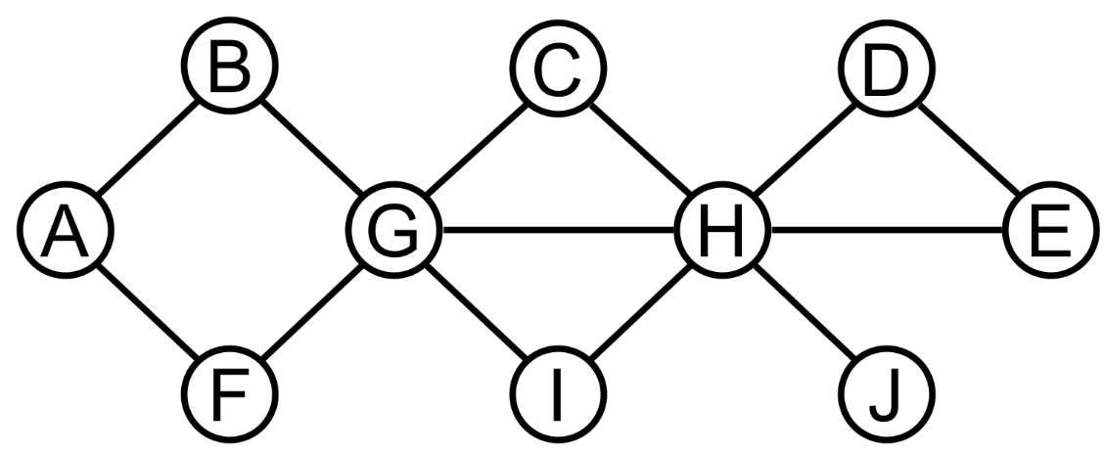  Fig.4(b) | CO2 | (08)
 | c) | Design an algorithm for sorting numbers using divide and conquer method. | CO2 | (06)
 |  | UNIT- III
5. | a) | What is a Greedy Algorithm? Write the interval scheduling algorithm using greedy approach. Explain the running time of the algorithm. | CO4 | (06)
 | b) | Construct the Huffman tree for the following symbols. Find the code words and average code word length. | CO4 | (06)
  Symbols | a | b | c | d | e | f
  Frequency | 8 | 2 | 4 | 5 | 10 | 1
 | c) | Define minimum cost spanning tree. Find the minimum spanning tree for the following graph using Prim’s algorithm.  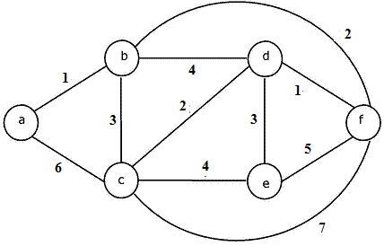  Fig.5(c) | CO4 | (08)
6. | a) | Write the Single Source Shortest Path Algorithm. Explain its applications. | CO4 | (06)
 | b) | Prove that “Greedy algorithm for interval scheduling returns an optimal set A”. | CO4 | (06)
 | c) | Apply the Minimizing the Maximum Lateness approach for the following set of intervals. | CO4 | (08)
   | 1 | 2 | 3 | 4 | 5 | 6
  Ti | 3 | 5 | 2 | 2 | 2 | 1
  Dj | 14 | 7 | 4 | 11 | 5 | 2
 |  | UNIT- IV
7. | a) | Compute the maximum subset-sum that can be achieved for the following items with maximum capacity W=8. | CO4 | (07)
  Item | Weight
  1 | 1
  2 | 2
  3 | 7
  4 | 5
 | b) | Apply bellman ford algorithm to find the shortest distance to all the other nodes from source vertex ‘u’.  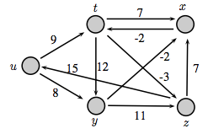  Fig.7(b) | CO4 | (08)
 | c) | Discuss survey-design problem for a given set of customers and products with an algorithm. | CO4 | (05)
8. | a) | Compute the maximum value or profit from the given n items and their weights wi using Knapsack. | CO4 | (08)
  Items | Weights | Values | W=6
  1 | 1 | 20 | W=6
  2 | 3 | 15 | W=6
  3 | 3 | 10 | W=6
  4 | 4 | 25 | W=6
 | b) | Design a memoization procedure to determine the maximum weight for a given set of n intervals, and each interval having a weight w. | CO4 | (05)
 | c) | Use ford Fulkerson algorithm to identify the maximum flow between source vertex 0 and destination vertex 5.  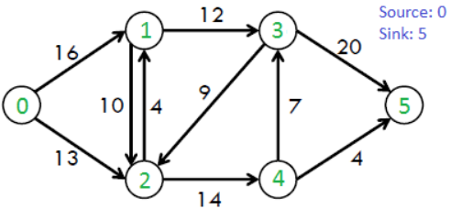  Fig.8(c) | CO4 | (07)
 |  | UNIT- V
9. | a) | Define P, NP, NP-Complete & NP-Hard problems. Give examples. | CO5 | (06)
 | b) | Explain the general strategy to prove NP-Complete problems. | CO5 | (06)
 | c) | Find Hamiltonian cycle in the given directed graph.  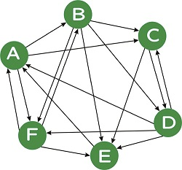  Fig.9(c) | CO5 | (08)
10. | a) | Explain polynomial time reduction with respect to Independent set problem. | CO5 | (10)
 | b) | Explain how the Circuit Satisfiability is a NP-Complete problem. | CO5 | (10)

****************

